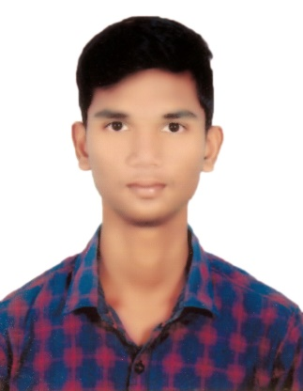5a358fef07fbb3.4535094415134596950327.pngkisspng-iphone-computer-icons-telephone-clip-art-contact-phone-icon-5ab06aba56e4d0.4008015415215110983559.png

I hereby declare that the above furnished information is true to the best of my knowledge.

Signature

(Rahul V)

* Secured State 3rd Rank in APECET-2020.
* Got merit certificate in school and college level.
* Completed 6 months internship in Centre Of Excellence (AU).
* FATHER NAME : V. Srinivasa Rao
* DATE OF BIRTH : 13-09-2001
* NATIONALITY : INDIAN
* GENDER : MALE

**Core skills**

CNC Coding

**Design**

AutoCAD, NX, Catia

**MS Office**

Word, Excel, PowerPoint

D. no. 11-135,

Lumburu vari street,

Palakonda,

Parvathipuram manyam,

Andhra Pradesh -532440.

+91 6300923237

vappangirahul7777@gmail.com

**Technical Skills**

**Languages**

Student

Place : Visakhapatnam

Date : 25-07-2022

* Reading Books
* Watching movies, listening songs

**Interests**

Hindi

English

Telugu

**Skills**

* Adaptability
* Trouble shooting
* Time management

**Declaration**

**Personal Profile**

**Achievements/Certificateons**

**Bachelor of Technology (2020-23)**

Andhra University College of Engineering, Visakhapatnam

* Course - Mechanical Engineering
* CGPA – 8.00

**Diploma (2017-20)**

Government Polytechnic, Amadalavalasa

* Course – Mechanical Engineering
* Percentage – 92.09

**SSC (Year of Passing - 2017)**

Gayatri English Medium School, Palakonda

* CGPA – 9.8

**Education**

To pursue a challenging career and be a part of progressive organization that gives a scope to enhance my knowledge and utilizing my skills towards the growth of the organization.

RAHUL VAPPANGI